Copenhagen Infrastructure Partners P/S  Amerika Plads 29  DK-2100 København Ø  Denmark  Sent by email to: cip@cip.dk | Asociación Plataforma  a favor de los paisajes de Teruel  Plaza de España, 3.  44560 Castellote (Teruel)  Spain  plataformapaisajeteruel@gmail.com

Reference: Letter to Copenhagen Infrastructure Partners P/S about the impact of its investment in the Maestrazgo area, Teruel (Spain)

Date: Teruel, December 26, 2022

Dear sirs,
Copenhagen Infrastructure Partners P/S (hereinafter ¨CIP¨) is a fund that works on the development of renewable energies. As one of its achievements CIP states that they use investors capital to invest in a sustainable and ethical way. Additionally, CIP guarantees to its investor the good management of their funds such as the adequate ecological impact of the investments on the planet, in particular, encouraging life and health of its inhabitants.
We are addressing this letter to your attention as it is public that the developer of this renewable energy project is a company based in Madrid (with many other projects developed in Aragón). That company has agreed to sell those projects once developed to CIP.
Please note that we do support the transition to a new energy model based on the development of renewable energy projects as a substitute to mineral resources used as fossil fuels. In this particular case, however, if the renewable project would be developed in a degraded area, an area with low environmental value or with great impact for people, we would understand its purchase and its investment but this project is far from that scenario.
In this particular case, we cannot understand that areas which are extremely rich and protected in terms of natural resources, biodiversity and landscape (due to its biota and its incredible geology), which are vulnerable to renewable energy projects, will be developed where they are planned to be placed. Those areas are crucial to the preservation of biodiversity in our region classified as areas of the Natura 2000 Network, Zone for Special protection for birds (ZEPA) and SCI Site of Protected Habitats (SCI), Important Areas for the Conservation of Birds (IBIAS areas) such as the Bearded Vulture (Gypaetus barbatus) and the Azor-Barrel Eagle (Aquila Fasciata) Common Vulture (Neophron percnopterus) Golden Eagle (Aquila Chrysaetus), Griffon Vulture (Gyps fulvus), among others.
We want to bring to your attention that CIP may have received wrong information, or it may have not received a complete picture of the consequences of developing the project where it is intended to be developed as we understand that CIP investments support sustainability, contributes to the preservation of the planet and its rich biodiversity.
We believe that CIP investors are not going to be very satisfied with the purchase and development of this project. The reputation of a fund like CIP may suffer, after years of working with the ethics of sustainability as its main goal.
For all these reasons, we ask you to reconsider the purchase and development of this project as an ethical or sustainable investment. Please note that you are going to cause a strong impact and degradation of an area protected and with astonishing natural and environmental value.
Thank you very much for your attention and sorry for any inconvenience we may cause.
Wishing you happy holidays and a good start to the new year.
Best regards,

______________________
By:
As:
Asociación Plataforma a favor de los paisajes de Teruel
Please contact us for further info at plataformapaisajeteruel@gmail.com

Additional relevant information:
- Annex 1: Video Maestrazgo https://youtu.be/0LRQEGAI86o

- Annex 2: Map of vulnerable areas to be excluded from the implementation of renewable energy parks or plants:

Annex 2
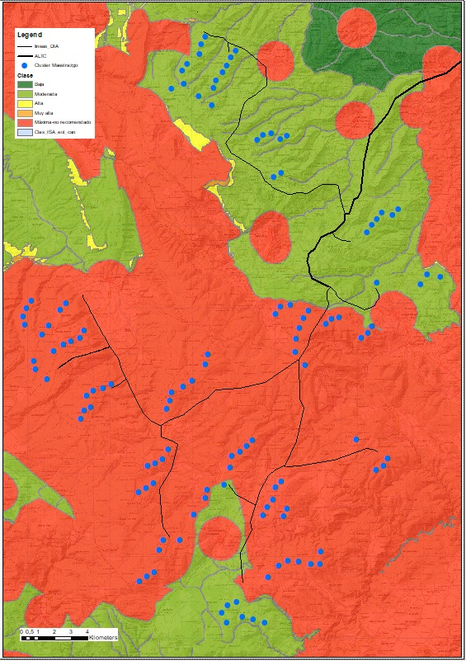

Natura 2000 is a network of core breeding and resting sites for rare and threatened species, and some rare natural habitat types which are protected in their own right. It stretches across all 27 EU countries, both on land and at sea. The aim of the network is to ensure the long-term survival of Europe's most valuable and threatened species and habitats, listed under both the Birds Directive and the Habitats Directive.

